Methods
R-Tree
R-trees are a method of indexing multidimensional information for efficient insertion, deletion, and searching. The R-tree is a tree-based data structure that resembles B-trees, but is modified to support indexing multidimensional data using hierarchical Minimum Bounding Rectangles (MBRs) or “bounding boxes” (Wikipedia, “R-tree”). The data structure works by maintaining internal nodes comprised of a pointer to the children of the node, in addition to the MBR, which encompasses all the MBR entries of its children. All objects that are inserted may fall within multiple (potentially overlapping) MBRs. Every object inserted into the tree has an MBR that is contained inside the MBR of every parent node. Any internal node MBR encompasses all the MBRs of its children all the way down to the leaves (See Figure 1).
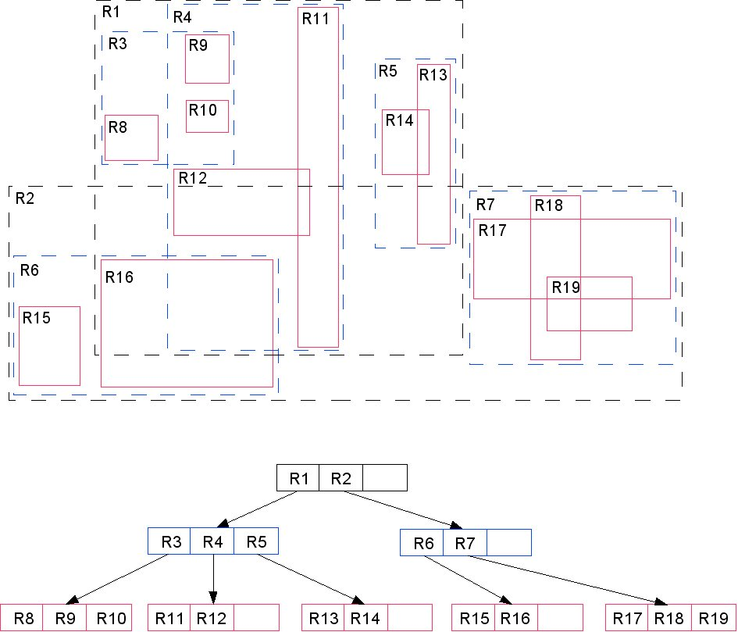
Figure 1: R-Trees: Objects for Insertion Followed by Resulting R-Tree (“R-Tree”, Wikipedia).

Searching, insertion and deletion uses the MBRs to search the tree. This is done by examining each MBR to determine if the object that is being searched resides within that MBR. If so, then the search travels down that section of the tree. When inserting a new entry, the MBRs are used to insert the new node in a branch of the tree that holds the elements that are “closest” to the new node (Wikipedia, “R-Tree”). Insertion begins at the root and recursively progresses until a leaf is reached. If the reached leave is full, then a split is performed and the tree is rebalanced before the insertion occurs (Wikipedia “R-Tree”). R-Trees can be used to produce data clusters by repeatedly inserting each element of a data set to build the entire tree. The resulting R-Tree is a cluster where each leaf grouping contains the elements that are closest to each other.
R-Tree Implementation
Due to the complexity of R-Trees and the time constraints of our study, for the Java implementation of R-Trees we adapted code from the Java R-Tree implementation by Håvard Tveite from the Norwegian University of Life Sciences (Tveite). The complexity of R-Trees results from the need to maintain a balanced tree that obeys the minimum and maximum branch factors and that also maintains the correct MBRs for each level of the tree. When an overflow occurs, then the tree must re-balance and adjust the MBRs of the internal nodes to maintain a consistent state. To allow direct comparison to the K-means and Hierarchical clustering methods our final implementation was based on the assumption that the R-Tree would only hold 2-dimensional point data and that it would not hold more complex shapes such as lines and polygons.
Clustering output
The clustering output of an R-Tree is the traversal of the child nodes. Each end branch of leaves is considered a separate cluster. Initial clustering tests showed that the algorithm worked as expected on random evenly distributed point data (See Figure 2). The overlap between the red and dark blue points results from overlapping MBRs, which is a characteristic of the R-Tree spatial indexing.
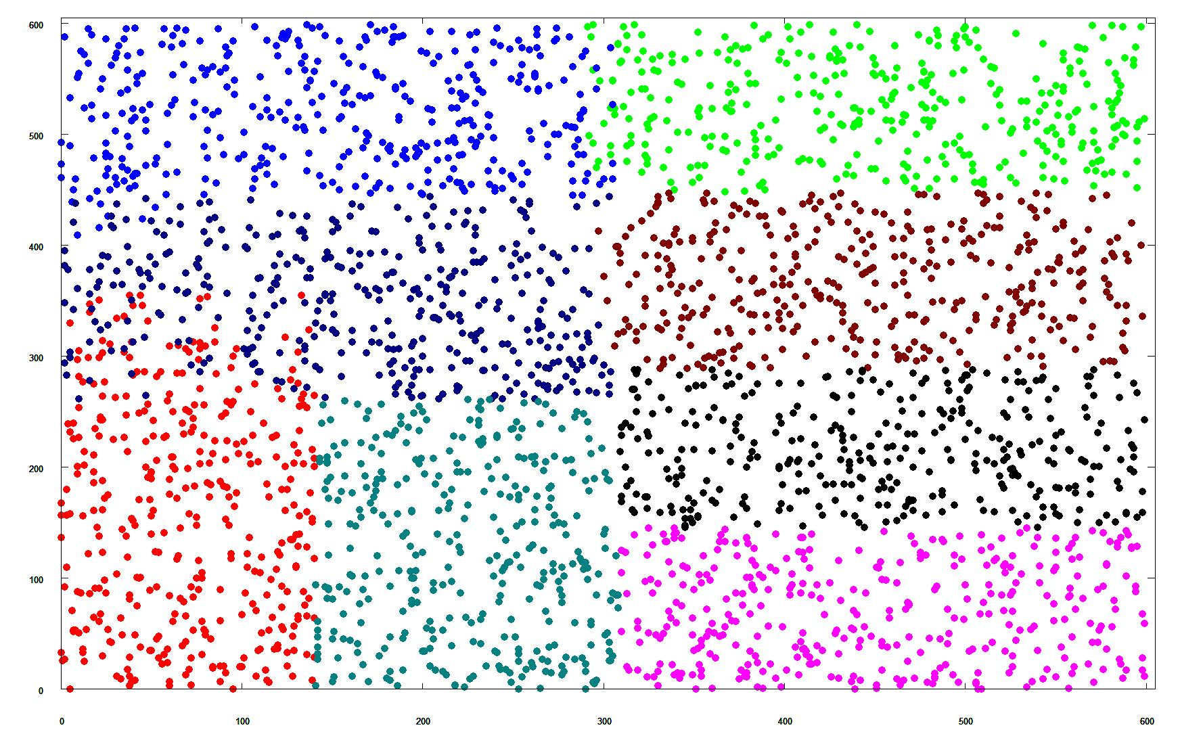Figure 2: R-Tree Cluster for Random Evenly Distributed Points with Overlap

Running R-Trees on natural clusters of data resulted in mixed results. The algorithm was able to detect clusters in many situations, but a few situations produced abnormalities that appear to be related to the the branching factors selected and the tendency for the algorithm to attempt to cluster evenly between branches of the tree. This abnormality produced some recognizable clusters but resulted in others being clearly different from the clusters that would be based on human perception (See Figure 3).
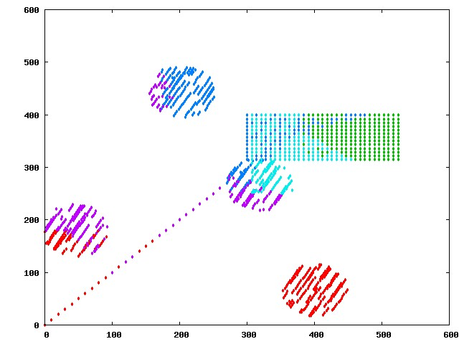Figure 3: R-Tree Resulting Clusters with Branch Factor of N / 6

Tveite, “Test R-Tree Demonstration.” Norwegian University of Life Sciences. 11 Dec. 2008
<http://gis.umb.no/gis/applets/rtree2/jdk1.1/>.

“R-Tree”. R-Tree. Wikipedia. 11 Dec. 2008 <http://en.wikipedia.org/wiki/R-tree>.

